Table of Contents
WEEK 3: PERIOD, LINEAR COMPLEXITY AND RANDOMNESS TESTING 2
Research: Randomness in Cryptography 3
1. Importance of Randomness 3
What is Randomness? 3
Why is Randomness Important? 3
Applications 3
2. Weak Random Generators 3
Definition 3
Characteristics of Weak Random Generators 3
Risks 3
Example 4
3. Historical Cryptographic Failures 4
A. Debian OpenSSL Bug (2006–2008) 4
Background 4
What Happened? 4
Impact 4
Lesson Learned 4
B. Weak Encryption Keys 4
Background 4
Example 4
Consequences 4
Lesson Learned 5
Comparison Table 5
WEEK 4: STREAM CIPHER CRYPTANALYSIS 6
Berlekamp–Massey Algorithm 6
Algebraic Attacks 7
RC4 Vulnerabilities 7
WEEK 5: BLOCK CIPHERS AND FEISTEL STRUCTURES 8
Assignment 1 8
Input 8
8
Output 8
Assignment 2 9
Mini Research Report: Block Cipher Concepts 9
1. DES (Data Encryption Standard) 9
2. AES (Advanced Encryption Standard) 9
3. Feistel Structure 9
4. Confusion and Diffusion 10
Confusion 10
Diffusion 10

WEEK 3: PERIOD, LINEAR COMPLEXITY AND RANDOMNESS TESTING

Research: Randomness in Cryptography

1. Importance of Randomness

What is Randomness?
Randomness is the absence of predictable patterns in data. In cryptography, random numbers are used to generate encryption keys, passwords, initialization vectors, nonces, and digital signatures.

Why is Randomness Important?
- Protects encryption keys: Strong random keys make it extremely difficult for attackers to guess or brute-force them.
- Ensures confidentiality: Predictable random numbers can expose sensitive information.
- Supports authentication: Many security protocols rely on random values to prevent replay attacks.
- Maintains system integrity: Secure random values prevent attackers from forging digital signatures or impersonating users.

Applications
- AES and RSA key generation
- SSL/TLS secure communications
- One-Time Pad (OTP) encryption
- Password generation
- Session tokens and cookies

2. Weak Random Generators

Definition
A weak random generator produces values that are predictable or follow a pattern, making cryptographic systems vulnerable to attacks.

Characteristics of Weak Random Generators
- Uses a small seed value
- Generates repeating sequences
- Relies on predictable sources such as system time
- Produces biased distributions of zeros and ones

Risks
- Encryption keys can be guessed.
- Passwords become easier to crack.
- Session IDs can be predicted.
- Attackers may impersonate legitimate users.

Example
If a random generator always starts with the current timestamp, an attacker who knows approximately when the key was created may be able to recreate the same "random" key.

3. Historical Cryptographic Failures

A. Debian OpenSSL Bug (2006–2008)

Background
A change made to OpenSSL in the Debian Linux distribution accidentally removed most of the entropy (randomness) used for generating cryptographic keys.

What Happened?
- Only a very small number of possible keys could be generated.
- SSH keys, SSL certificates, and other cryptographic keys became predictable.
- Millions of systems were affected.

Impact
- Attackers could generate the same keys as legitimate users.
- Secure connections became vulnerable.
- System administrators had to regenerate all affected keys.

Lesson Learned
Never modify or weaken cryptographic random number generators without thorough security analysis and testing.

B. Weak Encryption Keys

Background
Some systems generate keys using weak or predictable random values.

Example
Instead of generating a truly random 128-bit key, a developer might use:

Password123

or

CurrentDate2026

These keys have low entropy and are easily guessed using dictionary or brute-force attacks.

Consequences
- Encrypted files can be decrypted quickly.
- User accounts may be compromised.
- Sensitive information may be exposed.

Lesson Learned
Always generate keys using cryptographically secure random number generators (CSPRNGs), such as those provided by modern operating systems and cryptographic libraries.

Comparison Table
Aspect | Strong Random Generator | Weak Random Generator
Predictability | Very low | High
Key Security | Strong | Weak
Entropy | High | Low
Suitable for Cryptography | Yes | No
Risk of Attack | Minimal | Significant

WEEK 4: STREAM CIPHER CRYPTANALYSIS
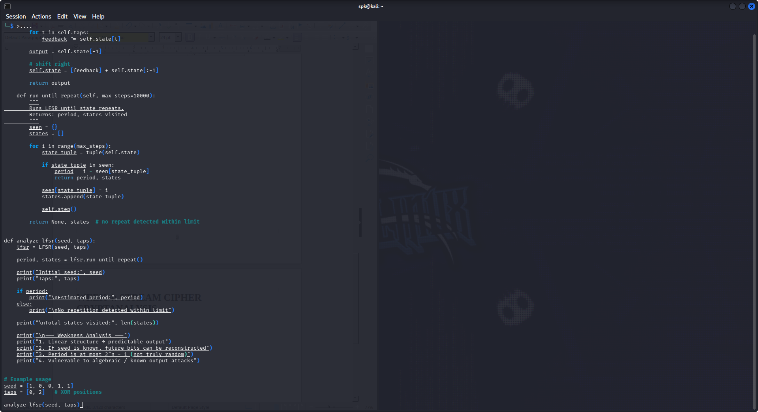

Berlekamp–Massey Algorithm
- Finds the smallest LFSR that can generate a given bit sequence.
- Helps recover the internal pattern (state) of a stream cipher.
- If enough output bits are known, it can rebuild the whole system.

Algebraic Attacks
- Break cryptosystems by turning them into math equations.
- Then solve the equations to find the secret key.
- Works well when encryption is too simple or linear.

RC4 Vulnerabilities
- RC4 is an old stream cipher that is now broken.
- Early output bits are not random (biased).
- Weak key setup allowed attackers to recover keys (e.g., Wi-Fi WEP).
- It is no longer considered secure.

WEEK 5: BLOCK CIPHERS AND FEISTEL STRUCTURES

Assignment 1

Input
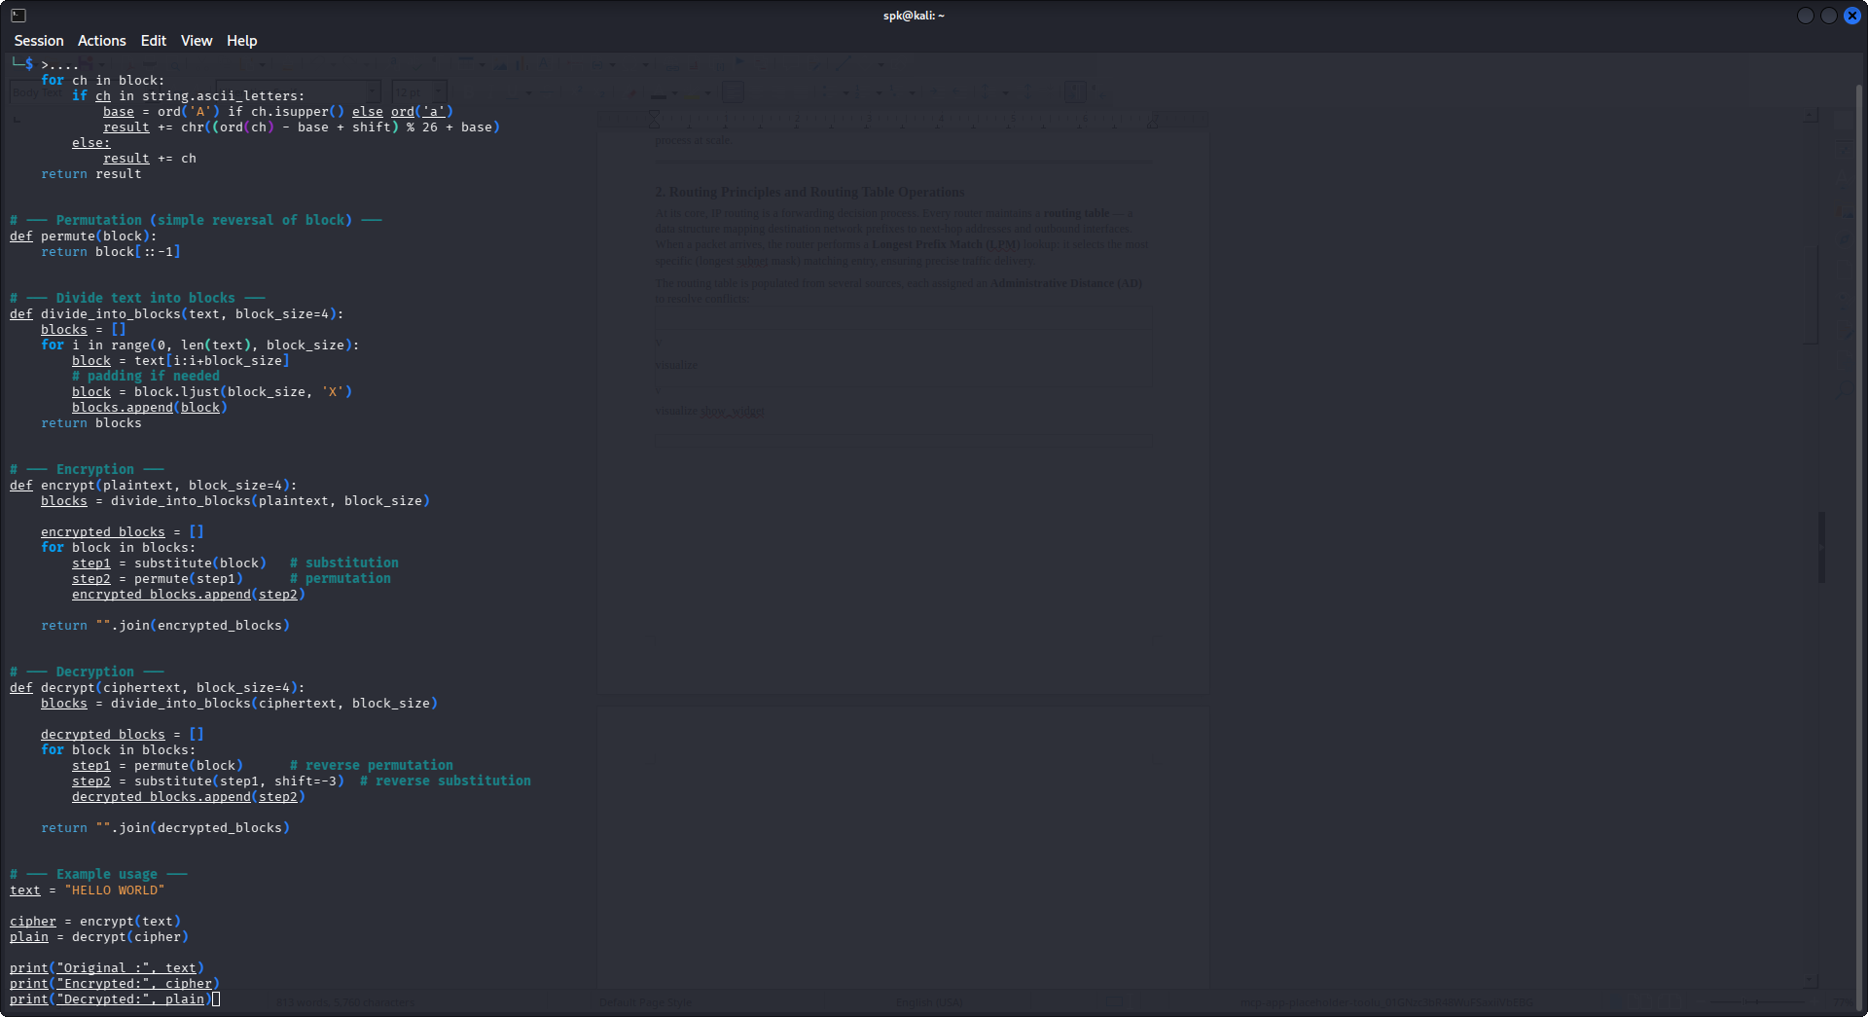

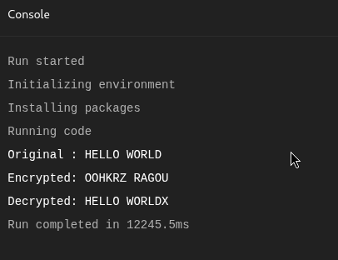
Output

Assignment 2

Mini Research Report: Block Cipher Concepts

1. DES (Data Encryption Standard)
- An old block cipher developed by IBM.
- Works on 64-bit blocks with a 56-bit key.
- Uses a Feistel structure with 16 rounds.
- Now considered insecure because the key size is too small and can be brute-forced.

2. AES (Advanced Encryption Standard)
- Modern encryption standard used today.
- Works on 128-bit blocks with key sizes of 128, 192, or 256 bits.
- Uses a substitution–permutation network (SPN) structure.
- Considered highly secure and is widely used in Wi-Fi, banking, and HTTPS security.

3. Feistel Structure
- A design model used in block ciphers such as DES.
- Splits data into two halves: Left (L) and Right (R).
- Each round applies a function to one half and combines it with the other.
Formula:
L(i+1) = R(i)
R(i+1) = L(i) XOR F(R(i), key)
- Advantage: Encryption and decryption use the same structure.

4. Confusion and Diffusion

Confusion
- Makes the relationship between the key and ciphertext complex.
- Achieved using substitution methods (S-boxes).

Diffusion
- Spreads the influence of plaintext across the ciphertext.
- Achieved using permutation and mixing operations.

